

PHYSICS

24/10/2019

8h30 am -11h30am

SENIOR FOUR END OF YEAR EXAMINATIONS, 2019

SUBJECT: PHYSICS THEORY

COMBINATIONS:
PHYSICS-CHEMISTRY-MATHEMATICS (PCM)
MATHEMATICS- PHYSICS- COMPUTER SCIENCE (MPC)
PHYSICS –CHEMISTRY- BIOLOGY (PCB)
MATHEMATICS –PHYSICS- GEOGRAPHY (MPG)

Marks:

/100

DURATION: 3 HOURS

INSTRUCTIONS:
- Do not open this question paper until you are told to do so.
- Answer all questions: 100 marks
- Use only a blue or black pen.

S4 PHYSICS EXAM, 2019

ATTEMPT ALL QUESTIONS (100 MARKS)

1) Match each of the following physical quantity with its meaning
Physical quantity | Meaning
1.Power | a)The capacity for doing work
2.Energy | b)Any interaction that can change the motion of an object
3.Work | c)The rate at which work is done
4.Potential energy | d)Energy transfer that occurs when an object is moved over a distance by a force applied in the direction of the displacement
5.Force | e)Energy possessed by an object because of its position

(5 marks)

(5 marks)

2) a) Complete the following statement with appropriate term related to
static equilibrium. Write only the answer in your answer booklet

(i) A filter funnel that is balanced upright on a table on its narrow
tip is in ……………………………………..equilibrium (1mark)
(ii)A filter funnel lying horizontally on its side at rest on a table
is in ……………………………………….equilibrium (1mark)
(iii) Another type of equilibrium not mentioned above is …
…………………………………equilibrium (1mark)
b) If a walking stick with a mass of 300 g can be balanced by
placing a mass M of 120 g at a distance L of 30 cm from the
fulcrum.
Determine the position of the centre of gravity of the stick with
respect to the fulcrum (2 marks)

3) a) What is compound microscope used for? (1mark)
b)(i)What is myopia/nearsightedness ? (1mark)
(ii)How is myopia corrected? (1mark)
c) The focal lengths of objective lens and eyepiece lens of a
telescope are respectively f_{o}=100 cm and f_{e} =8 cm .
What is the telescope magnification when the eye is relaxed?
(2 marks)
4) A gas has a volume of 0.02 m³ at a pressure of 2x10⁵ Pa and a
temperature of 27°C.It is heated at constant pressure until its
volume increases to 0.03 m³ .
a) Find the work done by this expanding gas (2 marks)
b) (i)Convert 27° C to Kelvin (1mark)
(ii)What is the new temperature of the gas? (2 marks)

5) a) Enumerate any two factors on which the acceleration due to gravity
depends (2 marks)
b) The mean distance of Earth from the Sun is 149.6 x10⁶ km and
the mean distance of Mercury from the Sun is 57.9 x10⁶ km.
The period of the Earth’s revolution is 1 year.
Use Kepler’s law of planetary motion to determine the period of
Mercury’s revolution (3 marks)

6) a) What is meant by the term energy degradation ? (1 mark)

b) Explain energy transformation in hydropower plant (4 marks)

7) a) What do you understand by the following terms ?
(i)Fossil fuel (1mark)
(ii) Renewable energy (1mark)
b) Identify the energy resources used in Rwanda related to
(i) fossil fuels (3 marks)
(ii) renewable energies (5 marks)

8) a) Differentiate between the inner planets and outer planets of the
solar system basing on their characteristics (2 marks)
b) List the inner planets (called terrestrial planets) of the solar
system (4 marks)
c) Identify the outer planets (called Jovian planets or gas giants)
of the solar system (4 marks)

9) a) State Kirchhoff’s laws (2 marks)
b) You are provided with two resistors of 3 Ω and 6 Ω, a dry cell
of electromotive force 4 V and connecting wires.
The internal resistance of the dry cell is negligible.
Use these electrical components to draw a labelled electric circuit
comprising the two resistors in parallel (2 marks)
c) Use Kirchhoff’s laws to determine the electric currents I, I₁,I₂
through each resistor in the circuit below

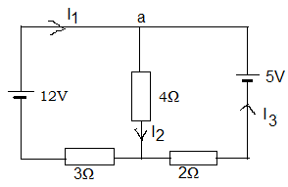
(6 marks)
10) a) A point object is moving along a circular path of radius 5 cm at
the linear speed of 200 π cm/minute
What is the period of this point in seconds? (2 marks)
b) A car of mass 2000 kg is turning around a circular path of radius
50 m at the constant speed of 36 km/h
(i)Express the speed in m/s (1 mark)
(ii)What is the centripetal force acting on this car? (2 marks)
c) An object is launched at a velocity of 20 m/s in the direction
making an angle of 25° with the horizontal.
Acceleration due to gravity is 9.81 m/s²
Find
(i) The time required to reach the maximum height (2 marks)
(ii) The maximum height reached by the object (2 marks)
(iii) The total flight time (between launch and touching the ground)
of the object (1 mark)

11) a) Two point charges Q =8 µC and Q’= -5 µC are separated by a
distance r=10 cm. The constant k=9x10⁹ Nm²C⁻²
(i)Calculate the magnitude of electrostatic force that the charge Q
exerts on Q’ (2 marks)
(ii) Draw not to scale, the direction of the force that each point
charge experiences (2 marks)
(iii)Are these forces attractive or repulsive? (1mark)
b) Two parallel plates separated by a distance of 1cm have a
potential difference of 20 V between them.
The plates are held in horizontal position with the negative
plate above the positive plate as shown below.
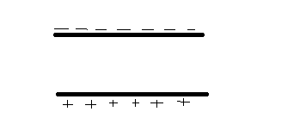

An electron is released from rest in the upper plate.
The mass and charge of the electron are respectively 9.11x10⁻³¹kg
and 1.6 x10⁻¹⁹C.
(i)What is the electric field strength created between the plates?
(2 marks)
(ii)What is the electric force exerted on the electron?
The weight of the electron is negligible (1mark)
(iii)What is the acceleration of the electron? (2 marks)
(iv)Copy the diagram and add the direction of the electric
field lines between the plates and the direction of the
electric force exerted on the electron (2 marks)

12) a) Use True or false to answer the following sub questions
(i) The speed of light in vacuum is 3x10⁸ m/s and the refractive
index of water is 4/3.
Therefore the speed of light in water is 2.25 x10⁸ m/s (1mark)
(ii)Concave lens is converging lens (1mark)
(iii)The image formed when you use convex lens as a magnifying
glass is real (1mark)
(iv)The power of a converging lens whose focal length is 8 cm
is 12.5 D(dioptres) (1mark)
b) A 1cm object AB is placed perpendicular to the principal axis of a
convex lens of focal length 2 cm.
Use ray diagram to find graphically (Don’t use calculations)
(i)the image position when the object is at a distance 4 cm from
the lens . (4 marks)
(ii) image size (2 marks)
(iii)properties of the image (2 marks)
c) A light ray fall perpendicular to one of the face of a glass prism of
angle 60° and refractive index 1.5 as shown below

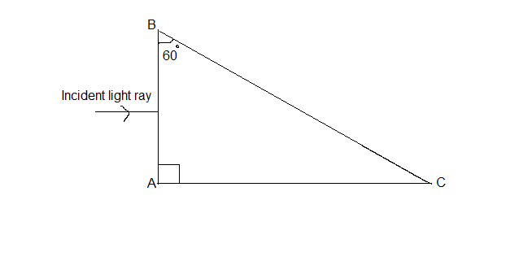

(i)Copy the diagram and show how the light ray passes through
the face AB (1mark)
(ii)Determine the angle of incidence at the second face BC
inside the prism (1 mark)

(iii) Determine the critical angle for this prism (2 marks)
(iv)What will happen to the incident ray at the face AB?
Explain (2 marks)

