COMPREHENSIVE ASSESSMENT 2020-2021
P5 SET MARKING SCHEME
1) a)True(1mark)
b)False(1mark)
2)
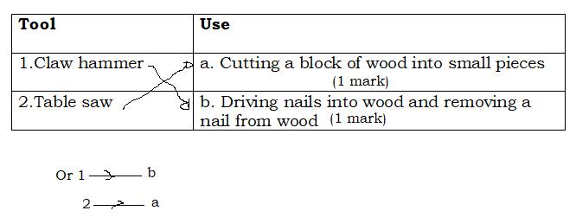
3) a)A simple definition which is at the level of P5 learner
Electricity is a form of energy (1mark) or electricity is electrical energy
b) Electricity is used for
Lighting (1mark) Cooking, charging telephones, cooling/refrigeration,
operating appliances, public transportation etc.
4) Keeping them in a dry, cool and clean place (1mark)
Use them for the purpose they are designed for
Use them carefully
Wooden objects should be hung on a rack
Learning objects should be mounted on a soft board and displayed in
school
Learning objects can be put in shelves, box
5) It refracts (1mark)
Accept also It reflects because a very small amount of the incident light is
reflected off water.
6) a)Knife (1mark) razor blade saw ,hammer, nails or any example of wedge
b) Sorghum straws (1mark) Small flexible tree sticks with a sharpened
end, string/thread, wires
Learner can also make toy house from clay, he can use hoe, plastic
, sorghum sticks, clay, water etc.
7) a)Masonry is the art of building house (1 mark) bridge or any structure
from individual units such as stones, bricks which are laid together by
mortar, clay etc. Or the art or occupation of mason
b) Wheel barrow is agricultural tool or masonry tool used for transport
(1mark)
8) a)Good conductor of heat(1mark) shiny, good conductor of
electricity, hard, sonorous
b)Protect metal against rust (1mark)or corrosion
9) Metal is very hard (1mark) malleable, ductile
10) a)We don’t have alternative energy sources that can replace electricity
to operate for example a television (1mark)
b) Electricity can cause fire (1mark) electric shocks, burns, explosion
and death
11) The density of gold 19.3 g/cm³ means that a volume of 1cm³ of gold
has a mass of 19.3 g (1mark) or a mass of 19.3 g of gold occupies
a volume of 1cm³
Comprehensive Assessment P5

12) Play sound helps to play sound (1 mark)

13) i. b angles
iii. b script
- marks)
14) Uses of e – mail in real life (any two: 2 marks)
- It is easy to use
- It is the fastet and cheapest mean of communication
- E- mail is delivered across the world within seconds.
- Single message can be sent to several people across the world.
- We can send e- mail at any time.
15) c. True
d. True
(2 marks)
16) a. Internal storage: ROM, RAM, hard disk, hard drive, journal, RTF( Rich
text format), HTML ( Hyper text format), TXT ( Plain Text format).
b. External storage: Memory card, Flash disk, CDs, DVDs, External hard
disk, Floppy disk.
(2 marks)
17) USB: Universal Serial Bus.
WWW: World Wide Web.
(2 marks)

18) Examples of information you can download (any two: 2 marks)
- Images
- Videos
- Audios
- Text documents

19) Password (1 mark)

20) -To avoid the spread of COVD-19 (any one: 1 mark)
- To avoid inhaling dangerous gases

21) –Trowel (1 mark)

22) It stops soil erosion (1 mark)

23) (i) Lungs (1 mark)
(ii) Skin (1 mark)

24) - Have feathers (3 marks)
- Have two legs
-Are warm-blooded

25) Sensory organs (1 mark)

26) A balanced diet is a diet that contains all food values in the right amounts. (1 mark)

27) - Energy giving food (any one: 1 mark)
- Body building food
- Body protecting food

28) Adolescence is the change from childhood to adulthood. (1 mark)

29) –Syphillis ( any four: 4 marks)
- Herps
- Gonorrhoe
- Candidias
-HIV/AIDS

30) –Manuring (any two: 2 marks)
- Mulching
- Practice crop rotation
- Avoid soil erosion

