COMPREHENSIVE ASSESSMENT 2019

S4 MARKING SCHEME OF PHYSICS EXAM

1)
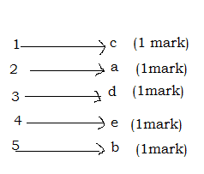

2) a)(i)unstable equilibrium (1mark)
(ii) Neutral equilibrium (1mark)
(iii) Stable equilibrium (1mark)
b) 300 x =120x30 (1mark)
x= 12 cm (1mark)

3) a) It is used to examine small objects that naked eye cannot
see(1mark) such microbes etc.
b) (i)The myopia is eye defect or the vision condition in which people
can see close objects clearly but objects farther away appear
blurred (1mark)
(ii)The use f concave lens /diverging lens with suitable focal length
(1mark)
c) (1mark)
(1mark)
Minus sign indicates that the image is inverted
Accept also M=12.5

4) a) W=PΔV (1mark)
= 2x10⁵ (0.03-0.02) J= 2x10³J (1mark)
b)(i) 27°C= (273+27)K=300 K(1 mark)
(ii) At constant pressure (1mark)
(1mark)

5)a) it depends on
Mass of the planets e.g. Earth (1mark)
Distance (depth or height) between the centres of mass of the object
and the mass of the planet(1mark)
It depends also on the rotation of the Earth (it is minimum at the
equator and maximum at the poles)
b) Kepler’s third law of planetary motion
The squares of the sidereal periods of revolution of the
planets are directly proportional to the cubes of their mean
distance from the sun
(1mark)
(1mark)
(1mark)

6)a) Degradation of energy is the transformation of energy into
some form in which it is less available for doing work (1mark)
b)In a hydropower plant, water is usually reserved in
constructions like a dam and it has potential energy (1mark).
This is converted into kinetic energy (1mark) and the turbine of the
hydropower plant converts the kinetic energy of falling water into
mechanical energy (1mark) because water hits its blades and
causing it to spin, then the generator converts the mechanical energy
from the turbine into electrical energy (1mark)

7)a)(i) Fossil fuel is a fuel formed by natural processes such as anaerobic
decomposition of buried dead organisms(plants and animals)
produced over a long time period (1mark)
(ii)Renewable energy is energy that is collected from renewable
resources which are naturally replenished on a human timescale
such as sunlight ,wind, tides etc. (1mark)
b)(i)Peat (1mark)
Methane gas (1mark)
Petroleum (1mark) or petrol, paraffin, diesel oil, oil
(ii)Sunlight (1mark) Hydropower plant (1mark) Biomass (1mark),
Biogas(1mark),Geothermal energy(1mark)

8) a) The inner planets are closer to the sun and are smaller and rockier
(1mark) while the outer planets are huge planets swaddled in gas
and all have the rings and moons (1mark)

- Mercury (1mark), Venus (1mark), Earth (1mark) and Mars (1mark)
- Jupiter(1mark),Saturn(1mark),Uranus(1mark),Neptune(1mark)

9) a) Kirchhoff’s current law(Junction rule)
The algebraic sum of all currents entering a circuit’s
junction and leaving the same junction must be equal to zero
(1mark)
Kirchhoff’s voltage law (Loop rule)
The algebraic sum of all voltages around any closed loop in an
electric circuit must be equal zero(1mark)
b)Labelled and well drawn circuit (2 marks)
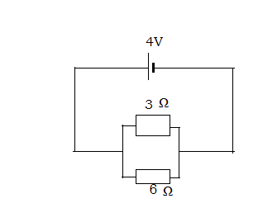
c) Junction a: I₂=I₁+I₃ (1)(1mark)

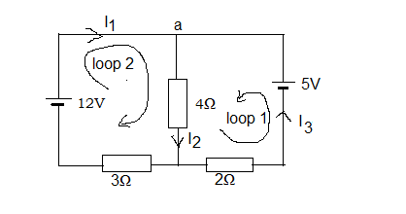
Loop 1: 5-4I₂ -2 I₃ =0 (2) (1mark)
Loop 2: 12 -4I₂-3I₁=0 (3)(1mark)

Substitute (1) into (2) and (3)

5-4 (I₁+I₃) -2 I₃ =0 (4)
12 -4 (I₁+I₃) -3I₁=0 (5)

5-4 I₁ -6 I₃ =0 (6)
12 -7 I₁-4 I₃ =0 (7)
Multiply (6) by -2 and (7) by 3
-10+8I₁+12I₃=0 (8)
36-21I₁-12I₃=0 (9)
Adding (8) and (9) member by member gives 26-13I₁=0
Then $I_{1}=\frac{\text{26}}{\text{13}}A=2A$(1 mark)
Use (7) to determine I₃
12-7x2-4I₃ =0
$I_{3}=−\frac{2}{4}A=−0\text{.}5A$ (1mark)
I₂=I₁+I₃
=2 A-0.5A=1.5 A (1mark)
10) a) The period (1mark)
(1mark)
b)(i)The speed of the car v=36 000 m/3600 s =10 m/s (1mark)
(ii)The centripetal force (1mark)
(1mark)
c) (i)The time to reach the maximum height(Vy=0)
0= -9.81 t+20 sin 25° (1mark)
(1mark)
(ii)The maximum height (1mark)
$h=−\frac{1}{2}x9\text{.}\text{81}m/{s^{2}}x{(0\text{.}\text{86}s)}^{2}+\text{20}m/{\text{sx}}0\text{.}0\text{.}\text{423}x0\text{.}\text{86}s=3\text{.}\text{65}s$(1mark)

(iii) The flight time of the object is t’=2t
=0.86 s x2= 1.72 s (1mark)
Or $−\frac{1}{2}x9\text{.}\text{81}x{t'}^{2}+\text{20}x0\text{.}\text{423}t'=0$

$t'(−\frac{1}{2}x9\text{.}\text{81}\text{xt}'+\text{20}x0\text{.}\text{423})=0$

11)a) (i)The electrostatic force (1mark)

$F=9x{\text{10}}^{9}x\frac{8x{\text{10}}^{−6}x5x{\text{10}}^{−6}}{({{\text{10}}^{−1})}^{2}}N=\text{36}N$(1mark)

(ii)
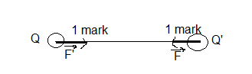

(iii)Attractive (1mark)

b)(i) Te electric field strength E=V/d(1mark)
=20 V/10⁻²m=2000 V/m (1mark)
or 2000 N/C
(ii)The electric force F=E
= (2000 N/C) x1.6x10⁻¹⁹ C=3.2 x10⁻¹⁶N (1mark)
(iii)Acceleration a=F/m (1mark)
=3.2x10⁻¹⁶ N/9.11x10⁻³¹kg =3.51x10¹⁴ m/s² (1mark)
(iv)
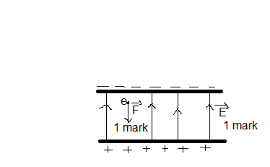

12) a)(i) True (1mark)
(ii)False (1mark)
(iii)False (1mark)
(iv)True (1mark)
b)(i)
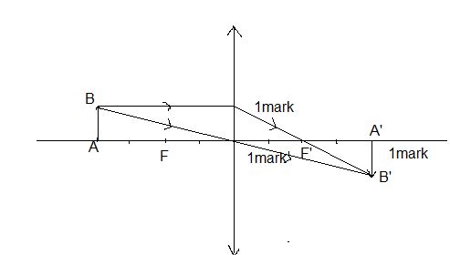
Image position p’=4 cm (1mark)
(ii)Measurement of the size of the image A’B’ is 1 cm
(2 marks)
(iii) Image is real (1mark) inverted (1mark)

c) (i) It passes without deviation .Angle of incidence is 0
thus the angle of refraction is 0
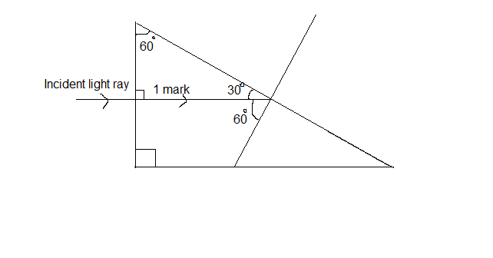
(ii) Angle of incidence is 90°- 30°=60° (1mark)
(See the diagram)
(iii) The critical angle c is given by (1mark)
c =41.8° (1mark)
(iv)It will undergo the total internal reflection (1mark)
The angle of incidence is greater than the critical angle
and the light ray passes from a more dense medium
to the less dense medium (1mark)

