
Chemistry

24/10/ 2019 08.30 AM - 11.30 AM

S1 END OF YEAR EXAM, 2019

SUBJECT: CHEMISTRY THEORY

DURATION: 3 HOURS
Instructions:
- There are 2 sections in this paper:
Section A (70 marks): Attempt all questions in this section
Section B (30 marks): Attempt 3 questions in this section.
- Do not use periodic tables
- Non-programmable calculators may be used
- Answers should be written on blank papers provided
- Use a blue or black pen only

SECTION A: Attempt all questions in this section (70 marks)
- Describe briefly by giving an example how chemistry helps people in:
- Foods and beverages industry in Rwanda (2 marks)
- Water treatment industry in Rwanda (2 marks)
- a) Write 2 laboratory rules and regulations. (2 marks)
b) Explain what you should do as a first aid in the laboratory in case an acid is poured on your hands accidentally. (2 marks)
3. a) Explain the advantage of using a bunsen burner rather than a charcoal stove in the laboratory. (2 marks)
b) Give and example of 1 substance that may undergo the following physical change: (2 marks)
i) Evaporation ii) Sublimation
c) State 2 methods that can be used to separate a heterogeneous mixture.
(2 marks)
4. a) The nucleus of an atom is made of protons and neutrons; indicate:
i) The charge and mass of a proton (2 marks)
b)Describe the term “element” as used in chemistry. (2 marks)
5.a) Explain the trends of metallic character across a period in the periodic table of elements (2 marks)
b) State the names of 2 noble gases (2 marks)
6.a) State 2 sources of water in nature (2 marks)
b) Explain the social-economic importance of water in Rwanda. (2 marks)
7.a) Write 2 important uses of carbon dioxide gas (2 marks)
b) Explain the cause of green house effect (global warming) in the earth”s atmosphere. (2 marks)
8.a) State 1 type of waste material (1 mark)
b) Describe “biodegradable solid waste” (2 marks)
9. a) Balance the following chemical equation: (2 marks)
C₃H_{8(g)} + O_{2(g)} → CO_{2(g)} + H₂O_{(l)}
b)State the law of conservation of matter (2 marks)
10.a) Describe the term “acid” (2 marks)
b) State 2 properties of alkalis (bases) (2 marks)
11.a) Sodium chloride is a salt. Write a chemical equation of the reaction to prepare sodium chloride NaCl (2 marks)
b) State one difference of observable changes that take place when Cu(NO₃)₂ and CuSO₄ crystals are heated in the laboratory. (1 mark)
12. a) Explain the effect of reduction of plants to the oxygen abundance in the earth”s atmosphere. (2 marks)
b) Study the diagram given below for the preparation of oxygen and answer the questions that follow:
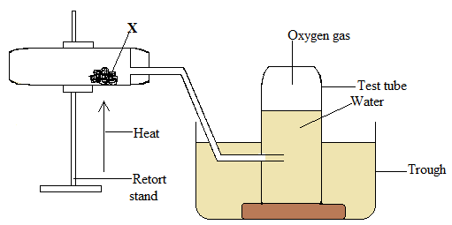

- Write the name or chemical formula of substance X (1 mark)
- Explain the importance of water in the trough. (1 mark)
- Write the chemical equation of the reaction of decomposition that takes place when X is heated. (2 marks)
13.a) Describe the term”freezing of a substance” (2 marks)
b) Explain the change in arrangement of particles from gaseous state to liquid state. (3 marks)
14.a) Give the names of 2 substances that undergo sublimation on heating.
(2 marks)
b) State 2 methods that can be used to separate a heterogeneous mixture constituted of a solid and a liquid substance. (2 marks)
15.a) Give 2 physical properties of pure water. (2 marks)
b) State 3 steps which are used during the treatment of water for drinking.
(3 marks)
16.a) Describe the importance of each of the following constituents of air:
(3 marks)
i) Nitrogen ii) Oxygen iii) Carbon dioxide
b) Give 2 pollutants of air and suggest one means that can be used to prevent pollution of air. (3 marks)
SECTION B: Attempt three questions in this section (30 marks)
17.a) Write the equation for the thermal decomposition of calcium carbonate.
(2 marks)
b) State the law of conservation of matter. (2 marks)
c) Write the product of the reaction given below for the industrial production of ammonia and balance the equation. (2 marks)
H_{2(g)} + N_{2(g)} →
d) Define the term “acid” (2 marks)
e) Write names of 2 natural acids. (2 marks)
18.a) Give 3 properties of alkalis. (3 marks)
b) State the colour of methyl orange indicator in: (2 marks)
i) Acid solution ii) Alkaline solution
c) Give 2 application (uses) of acids by man. (2 marks)
d) State 3 hazards that can be caused by acid rain. (3 marks)

19.a) State 2 uses of inorganic salts. (2 marks)
b) Give 2 physical properties of inorganic salts. (2 marks)
c) Copper sulphate CuSO₄ decomposes when it is heated strongly.
i) Write the chemical equation for the thermal decomposition of copper sulphate.
(2 marks)
ii) State the colour of the solid product formed after the decomposition. (1mark)
d) State 2 chemical substances that can be used to prepare oxygen gas in the laboratory. (2 marks)
e) Give one physical properties of oxygen gas. (1 mark)

20.a) Study the diagram given below and answer the questions that follow:
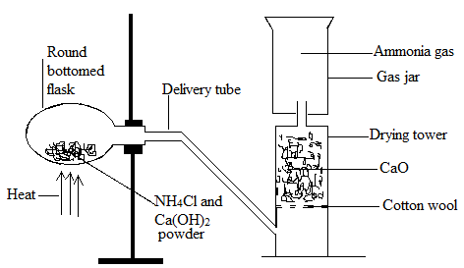
- Write the chemical equation for the reaction between ammonium chloride and calcium hydroxide powder. (2 marks)
ii) Explain why H₂SO₄ cannot be used to dry ammonia in this experiment instead of calcium oxide. (2 marks)
iii) State the method of collection of ammonia in the apparatus. 1 mark)
- Suggest a test reagent you can use to detect the presence of ammonia in the gas jar and describe the observable change if ammonia is present. (2 marks)
b) Describe the danger of carbon monoxide to man. (1 mark)
c) Suggest two ways you can advise people in your village to reduce air pollution. (2 marks)

