
Biology and Health sciences
18/06/2021
8h30 am -11h30am

SENIOR TWO END OF YEAR EXAMINATIONS, 2020/2021

SUBJECT: BIOLOGY AND HEALTH SCIENCES

Marks:

/100

DURATION: 3 HOURS

INSTRUCTIONS:
1) Do not open this question paper until you are told to do so.
2) Answer all questions in section A. (70 mark)
3)Answer three questions in section B. (30 marks)
4) Use only a blue or black pen.

SECTION A: Attempt all questions (70 marks)
1) Identify any five functions of the Liver in the human body. (5 marks)
2) Explain why it is biologically advisable to carry out physical exercises regularly.
(3 marks)
3) How can drug abuse affect your health? (4 marks)
4) Copy and complete the paragraph below using the following words:
Carbondioxide, cholorophyll, Energy, gas, glucose, light, oxygen, water.
During Photosynthesis……………………..energy is absorbed by ………………, a substance found in the chloroplasts. This …………………..is then used to convert……………….from the air and………………….from the soil into a simple sugar called………………
…………………is also produced and released as………………………
(8 marks)
5) The diagrams below represent two organisms in Kingdom Animalia. Observe them carefully and then answer the questions that follow.

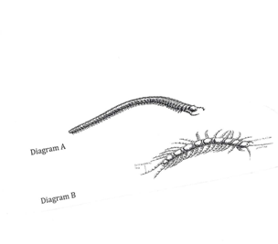
a) State the phylum and class of each organism.
Organism A
Phylum……………………………………………..
Class………………………………………………..
(2 marks)
Organism B
Phylum……………………………………………..
Class………………………………………………..
(2 marks)
b) State two observable characteristics features which are common to both organism A and B.

(2 marks)
6) Complete the table below using √ if the structure is present and X if it is absent in the
respective Animal and plant cells.
Structure | Animal cell | Plant cell
Nucleus
Cytoplasm
Cell wall
Cell Membrane
Permanent Vacuole

(5 marks)
7) A student in Senior Two carried out the following tests to investigate the food substances
present in a given food sample.
- Identify the observation at (a), (b) and (c) if all tests were positive.
Test procedure | Observation | Deductions
(i) To 1 cm³ of Solution containing starch in attest tube, add 2-3 drops of Iodine solution | (a) | Starch is present
(ii) To 1 cm³ of Solution containing glucose on a test tube, add 1 cm³ of Benedicts Solution and boil. | (b) | Reducing sugar present
(iii) To 1 cm³ of Solution, add dilute hydrochloric acid and heat. Cool under cold water, add Sodium hydroxide Solution and then add 1 cm³ of Benedicts Solution and boil. | (c) | Non reducing sugar present

(6 marks)
- When testing for non-reducing sugars, give one reason why each of the following was added.
(i) Dilute hydrochloric acid (1 mark)
(ii) Sodium hydrochloric solution (1 mark)

8) Name parts that:
(a) Attaches a bone to bone (1 mark)
(b) Attaches bones to muscles (1 mark)
(c) Acts as a shock absorber where two bones articulate. (1 mark)
9) Match the following pathogen with the disease they cause.
Pathogens Disease
- Vibro cholera a) Malaria
- Plasmodium b) AIDS
- Human Immunodeficiency virus c) Cholera
- Salmonella typhus d) Typhoid
(4 marks)
10) State five ways in which the alveoli are suited for their functions in humans.
(5 marks)
11) Suggest at least four ways how HIV is transmitted from an infected person to a healthy
person. (4 marks)

SECTION B: Attempt any three questions (30 marks)
12 a) What do you understand by the following terms:
- Turgidity (2 marks)
- Plasmolysis (2 marks)

b) Distinguish between transpiration and Evaporation. (2 marks)
c) How are Xerophytes adapted to avoid excess water loss? (4 marks)

13) The diagram below shows a feeding relationship that exists in an aquatic ecosystem.

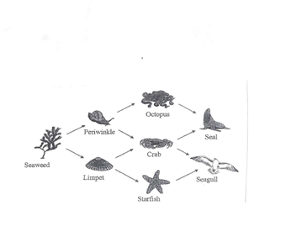
- Which Feeding relationship is shown on the diagram above? (2 marks)
- To which group of organisms does octopus, crab and Starship belong. (2 marks)
- Which organism is a producer on the diagram? (2 marks)
- In which trophic level does seal and seagull belong? (2 marks)
- What role is played by seaweed in this ecosystem? (2 marks)
14) The diagram below shows a human Urinary system. Use it to answer the questions that
follow.

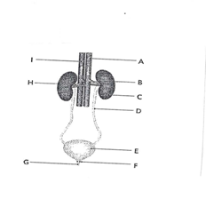

a) Name the parts A,B,C,D,E,F,G,H and I (4 marks)
b) State the Function of D and E (2 marks)
c) Name the substance that is
(i) Present in the Urine and human sweat (2 marks)
(ii) Present in blood but absent in Urine (2 marks)
15) Explain how the following ways help to prevent the spread of diseases.
a) Use of condom during sexual intercourse
b) Washing hands before preparing salads
c) Boiling water for drinking and keeping it in clear container
d) Putting your hand in front of your mouth while coughing
e) Avoid staying with hens and rabbits in the same house.
(10 marks)
SECTION C (Compulsory) 15 marks
16) The experiment below is used to demonstrate a biological process.
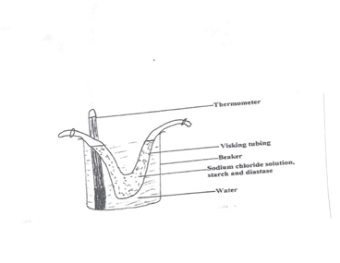
Visking tubing is made of material which acts as a semi-permeable membrane. After sometime, water from the beaker entered the Visking tubing and water in the beaker became salty. The temperature of the experiment was kept between 35 º C and 40º C throughout the experiment.
a) By what process has water entered the visking tubing? (1 mark)
b) Give an example of the process above occurring in (i) Animals
(ii) Plants
(4 marks)
c) By what process has salt (Sodium chloride) entered the beaker.
Give an example of the process in (C) above occurring in (i) Animals
(ii) Plants
- marks)
d) Identify one or more substances you think has entered the water in the beaker by the same
process as salt. (1 mark)
(e) Explain why osmosis is considered as a special case of diffusion. (4 marks)

