
Biology and Health sciences
18/06/2021

8h30 am -11h30am

SENIOR ONE END OF YEAR EXAMINATIONS, 2020

SUBJECT: BIOLOGY

Marks:

/100

DURATION: 3 HOURS

INSTRUCTIONS:
1) Do not open this question paper until you are told to do so.
2) Answer all questions in section A. (70 marks)
3) Answer three questions in section B. (30 marks)
4) Use only a blue or black pen.

SECTION A: All questions are compulsory (70 marks)
1) All living organisms are made of either one or many cells. Apart from this
characteristics feature, identify any five ways you can use to describe all
living things.
(5 marks)
2) Explain why it is healthy for you to carry out physical exercise regularly.
(3 marks)
3) How can drug abuse affect your health? (4 marks)
4) The following terms are used in Levels of organization in organisms.
Tissue, organ, cell, system, nucleus and organism. Arrange them in their
increasing order of size; from the smallest to the biggest. (6 marks)

5) The diagrams below represent a plant cell and an animal cell. Use them to
answer the following questions.

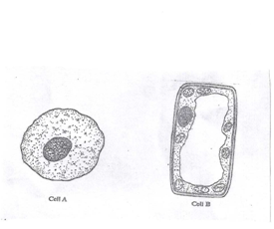
- Which of the above cells A and B is a plant cell? Give reason to support your answer.
(3 marks)
- State two parts which are found in Cell B but are not found in Cell A.
(2 marks)
- Identify three parts which are found in both Cell A and B.
(3 marks)
6 a) State four functions of the Human Skeleton. (4 marks)
b) Explain how you can maintain your skeleton system healthy.
(3 marks)
7 a) What do you understand by the term Multicellular organisms? (2 marks)
b) Why are plants and animals referred to as multicellular organisms?
(1 mark)
c) Copy and complete the table below. One example is done for you

Kingdom of Organism | Example of Kingdom
………………………….. | Human being
Plantae | ………………………………
……………………………. | Mushroom
………………………………… | Plasmodium
Monera | Vibrio cholera
(4 marks)
8) Identify three diseases caused by Viruses in humans. (3 marks)
9 a) Suggest two magnifying instruments used in the study of Biology in
your School. (2 marks)
b) Match the Following parts of a light microscope with their functions.

Part of a light Microscope Function

- Eye piece a) Where the eye is placed during
Observation
- Fine adjustment Knob b) Used when moving a microscope from one place to another
- Handle or arm c) Controls or regulates the amount
of light entering Microscope
- Diaphragm d) Makes images fine and clearly
observed.
(4 marks)
10) Explain why there is an increase in hips, thighs and breasts in girls during
adolescence. (3 marks)

11) Name the plant growth response towards,
a) Gravity
b) Light
c) Water
(3 marks)
12) A 13-year old girl wants to get married.
Can you support or discourage her?
Give your reasons.

(5 marks)
SECTION B: Answer any three questions (30 marks)
13) Your need food which contains nutrients for various functions in your
body.

- Suggest three resons to explain why food nutrients are needed in your
body. (3 marks)
b) Fish, milk, eggs and chicken are classified in the same class of food. Suggest
this class. (2 marks)
c) Complete the table below by filling in blank spaces

Food type | Deficiency disease
Vitamin | …………………………..
Iron | …………………………….
……………………………………. | Scurvy
………………………………………….. | Poor formation of bones in babies
…………………………………………….. | Night blindness

(5 marks)

14) State the five kingdoms, any four characteristics of each and any twoo
examples of organisms in each. (10 marks)
15) Explain each of the following biological statements.
a) Sperm cells have more number of mitochondria. (2 marks)
b) Red blood cells have haemoglobin. ( 2 marks)
c) Palisade Mesophyll cells contain numerous chloroplasts.
- marks)
- Root hair cells absorb water and mineral salts. (3 marks)
- Guard cells allow the opening /closing of stomata. (2 marks)

16) The following is a list of diseases: Cholera, Ebola, Diabetes,
Tuberculosis, Cancer.
- Which of the following diseases are infectious? Support your answer.
(6 marks)
- Write HIV in full. (1 mark)
- Identify three main ways through which a baby can acquire HIV from her HIV positive Mother.
3marks)
SECTION C (Compulsory) 15 marks

17) Use the diagrams below to answer the question that follow.

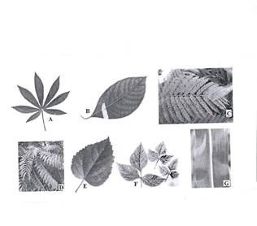

- Identify the letters which represent simple leaves. (4 marks)
- Give reason to support your choice above. (2 marks)
- How is leaf B structurally similar to leaf E and how are they different.
(4 marks)
- Identify letters which represent compound leaves. (3 marks)
- State Two general functions of a leaf. (2 marks)

